

**Data Analyst Project**

**Data Columns:**

1. Date
2. Time
3. Booking_ID
4. Booking_Status
5. Customer_ID
6. Vehicle_Type
7. Pickup_Location
8. Drop_Location
9. V_TAT
10. C_TAT
11. cancelled_Rides_by_Customer
12. cancelled_Rides_by_Driver
13. Incomplete_Rides
14. Incomplete_Rides_Reason
15. Booking_Value
16. Payment_Method
17. Ride_Distance
18. Driver_Ratings
19. Customer_Rating

**SQL Questions & Answers:**

1. **Retrieve all successful bookings:**

select * from bookings where Booking_Status='Success';

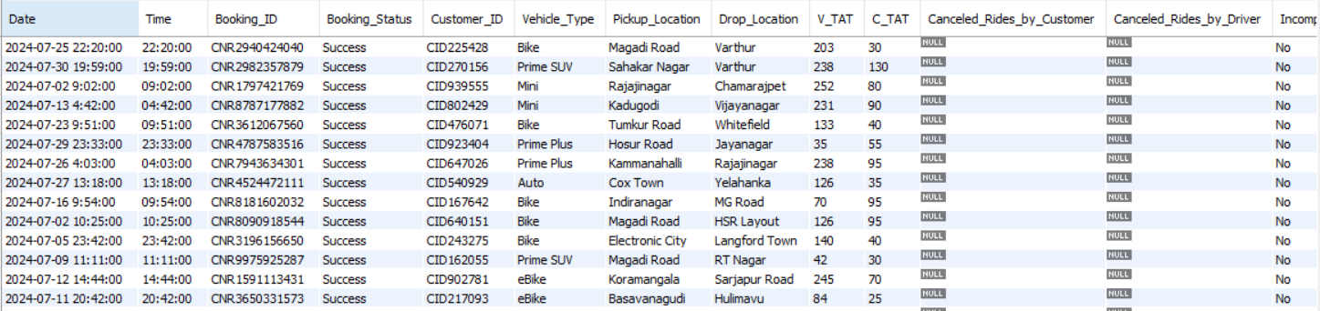

1. **Find the average ride distance for each vehicle type:**

select Vehicle_Type, avg(Ride_Distance) as Avg_Distance from bookings group by Vehicle_Type;

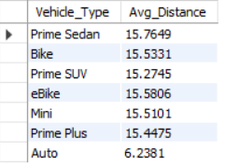

1. **Get the total number of cancelled rides by customers:**

select count(*) as cancelled_by_customers from bookings where Booking_Status = 'Canceled by Customer';



1. **List the top 5 customers who booked the highest number of rides:**

select Customer_ID, count(Booking_ID) as total_rides from bookings group by Customer_ID order by total_rides desc limit 5;

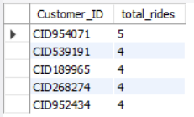

1. **Get the number of rides cancelled by drivers due to personal and car-related issues:**

select count(*) as cancelled_by_drivers_due_to_personal_and_car_related from bookings where Canceled_Rides_by_Driver='Personal & Car related issue';



1. **Find the maximum and minimum driver ratings for Prime Sedan bookings:**

select max(Customer_Rating) as Max_Rating,min(Customer_Rating) as Min_Rating from bookings where Vehicle_Type="Prime Sedan";



1. **Retrieve all rides where payment was made using UPI:**

select * from bookings where Payment_Method="UPI";

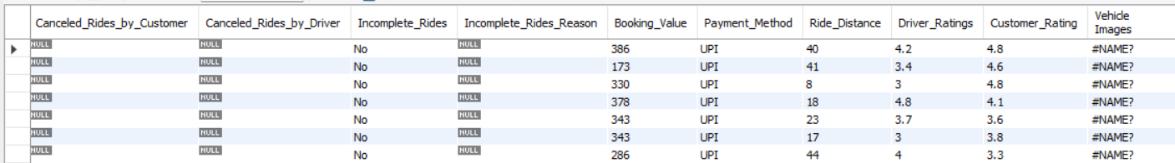

1. **Find the average customer rating per vehicle type:**

select Vehicle_Type, avg(Customer_Rating) as Avg_Customer_Rating from bookings group by Vehicle_Type;

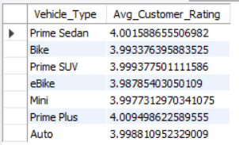

1. **Calculate the total booking value of rides completed successfully:**

select sum(Booking_Value) as total_successful_value from bookings where Booking_Status="Success";



1. **List all incomplete rides along with the reason:**

Select Booking_ID, Incomplete_Rides_Reason from bookings where Incomplete_Rides="Yes";

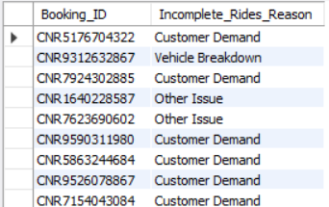

1. **Find the most popular pickup and drop locations based on the number of rides.**

-- Most Popular Pickup Locations

select Pickup_Location,count(*) as Ride_Count from bookings group by Pickup_Location order by Ride_Count Desc limit 5;

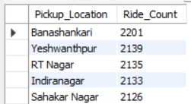

-- Most Popular Drop Locations

select Drop_Location,count(*) as Ride_Count from bookings group by Drop_Location order by Ride_Count Desc limit 5;

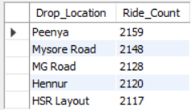

1. **Get the percentage of successful bookings for each vehicle type.**

select Vehicle_Type,count(case when Booking_Status='Success' then 1 end) / count(Booking_ID) * 100 as Success_Percentage from bookings group by Vehicle_Type order by Success_Percentage desc;

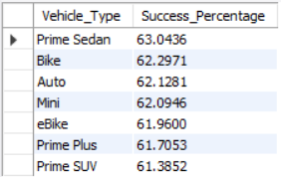

1. **Retrieve the total number of bookings made for each day of the week.**

-- By the help of GPT

SELECT

DAYNAME(STR_TO_DATE(Date, '%Y-%m-%d')) AS Day_of_Week,

COUNT(*) AS Total_Bookings

FROM bookings

GROUP BY Day_of_Week

ORDER BY FIELD(Day_of_Week, 'Sunday', 'Monday', 'Tuesday', 'Wednesday', 'Thursday', 'Friday', 'Saturday');

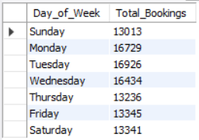

**SQL Questions & Answers:**

create database Ola;

use Ola;

SELECT * FROM ola.bookings;

# 1. Retrieve all successful bookings:

-- Creating View So that we can use it later(Easy Retrival)

create view SuccessfulBookings as

select * from bookings where Booking_Status='Success';

# 2. Find the average ride distance for each vehicle type:

-- View

create view average_ride_distance_for_each_vehicle as

select Vehicle_Type, avg(Ride_Distance) as Avg_Distance from bookings group by Vehicle_Type;

# 3. Get the total number of cancelled rides by customers:

-- View

create view cancelled_rides_by_customer as

select count(*) as cancelled_by_customers from bookings where Booking_Status='Canceled by Customer';

# 4. List the top 5 customers who booked the highest number of rides:

-- View

create view top_5_customers as

select Customer_ID, count(Booking_ID) as total_rides from bookings group by Customer_ID order by total_rides desc limit 5;

# 5. Get the number of rides cancelled by drivers due to personal and car-related issues:

-- View

create view cancelled_by_dri_due_to_per_and_car as

select count(*) as cancelled_by_drivers_due_to_personal_and_car_related from bookings where Canceled_Rides_by_Driver='Personal & Car related issue';

# 6. Find the maximum and minimum driver ratings for Prime Sedan bookings:

-- View

create view Max_Min_Rating_Prime_Sedan as

select max(Driver_Ratings) as Max_Rating,min(Driver_Ratings) as Min_Rating from bookings where Vehicle_Type="Prime Sedan";

# 7. Retrieve all rides where payment was made using UPI:

-- View

create view Payment_UPI as

select * from bookings where Payment_Method="UPI";

# 8. Find the average customer rating per vehicle type:

-- View

create view average_customer_rating_per_vehicle_type as

select Vehicle_Type, avg(Customer_Rating) as Avg_Customer_Rating from bookings group by Vehicle_Type;

# 9. Calculate the total booking value of rides completed successfully:

-- View

create view total_successful_booking_value as

select sum(Booking_Value) as total_successful_value from bookings where Booking_Status="Success";

# 10. List all incomplete rides along with the reason:

-- View

create view incomplete_rides_with_reason as

select Booking_ID,Incomplete_Rides_Reason from bookings where Incomplete_Rides="Yes";

# 11. Find the most popular pickup and drop locations based on the number of rides.

-- Most Popular Pickup Locations

-- View

create view MostPopularPickupLocations as

select Pickup_Location,count(*) as Ride_Count from bookings group by Pickup_Location order by Ride_Count Desc limit 5;

-- Most Popular Drop Locations

-- View

create view MostPopularDropLocations as

select Drop_Location,count(*) as Ride_Count from bookings group by Drop_Location order by Ride_Count Desc limit 5;

# 12. Get the percentage of successful bookings for each vehicle type.

-- View

create view SuccessfulBookingsPercentage as

select Vehicle_Type,count(case when Booking_Status='Success' then 1 end)/count(Booking_ID)*100 as Success_Percentage from bookings group by Vehicle_Type order by Success_Percentage desc;

# 13. Retrieve the total number of bookings made for each day of the week.

-- View

create view TotalBookingsMadeEachDay as

SELECT

DAYNAME(STR_TO_DATE(Date, '%Y-%m-%d')) AS Day_of_Week,

COUNT(*) AS Total_Bookings

FROM bookings

GROUP BY Day_of_Week

ORDER BY FIELD(Day_of_Week, 'Sunday', 'Monday', 'Tuesday', 'Wednesday', 'Thursday', 'Friday', 'Saturday');

**Retrieve All Answers (View)**

# 1. Retrieve all successful bookings:

select * from SuccessfulBookings;

# 2. Find the average ride distance for each vehicle type:

select * from average_ride_distance_for_each_vehicle;

# 3. Get the total number of cancelled rides by customers:

select * from cancelled_rides_by_customer;

# 4. List the top 5 customers who booked the highest number of rides:

select * from top_5_customers;

# 5. Get the number of rides cancelled by drivers due to personal and car-related issues:

select * from cancelled_by_dri_due_to_per_and_car;

# 6. Find the maximum and minimum driver ratings for Prime Sedan bookings:

select * from Max_Min_Rating_Prime_Sedan;

# 7. Retrieve all rides where payment was made using UPI:

select * from Payment_UPI;

# 8. Find the average customer rating per vehicle type:

select * from average_customer_rating_per_vehicle_type;

# 9. Calculate the total booking value of rides completed successfully:

select * from total_successful_booking_value;

# 10. List all incomplete rides along with the reason:

select * from incomplete_rides_with_reason;

# 11. Find the most popular pickup and drop locations based on the number of rides.

-- Most Popular Pickup Locations

select * from MostPopularPickupLocations;

-- Most Popular Drop Locations

select * from MostPopularDropLocations;

# 12. Get the percentage of successful bookings for each vehicle type.

select * from SuccessfulBookingsPercentage;

# 13. Retrieve the total number of bookings made for each day of the week.

select * from TotalBookingsMadeEachDay;

**Same Things Excel:**

# 1. Retrieve all successful bookings (Applied some conditional formatting)

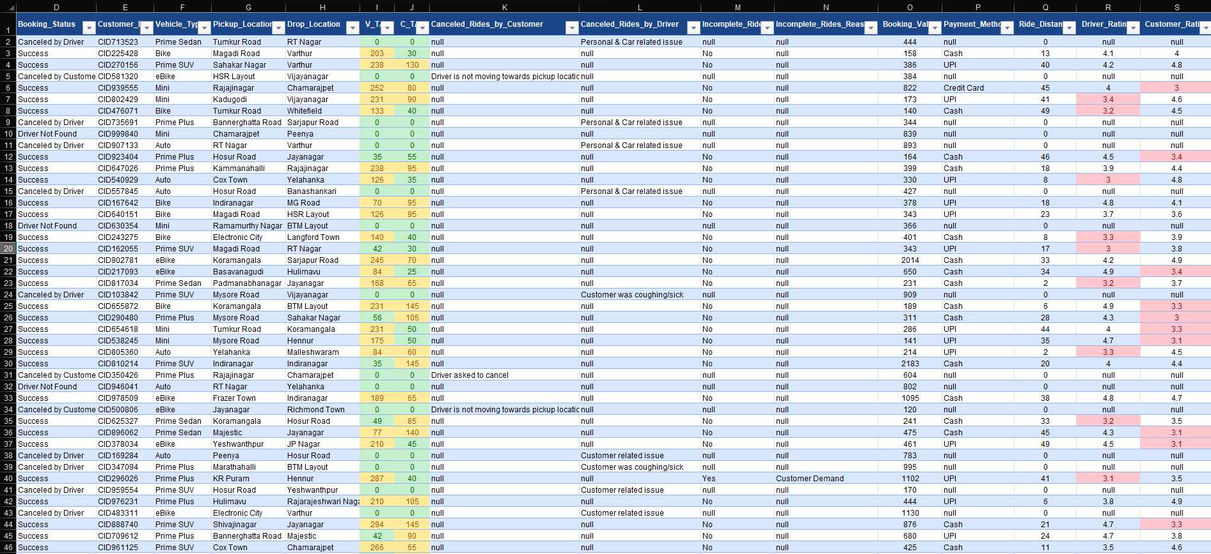

# 2. Find the average ride distance for each vehicle type:

=AVERAGEIF(July!F:F,Analysis!F2,July!Q:Q)

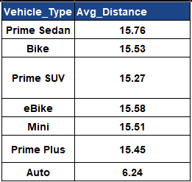

# 3. Get the total number of cancelled rides by customers:

=COUNTIF(July!D:D,"=Canceled by Customer")



# 4. List the top 5 customers who booked the highest number of rides: (Used Pivot Table)

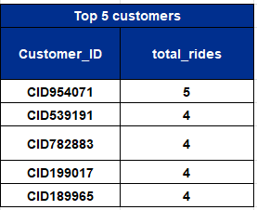

# 5. Get the number of rides cancelled by drivers due to personal and car-related issues:

=COUNTIF(July!L:L,"=Personal & Car related issue")

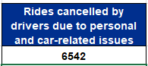

# 6. Find the maximum and minimum driver ratings for Prime Sedan bookings:

=MAXIFS(July!R:R,July!F:F,"=Prime Sedan")

=MINIFS(July!R:R,July!F:F,"=Prime Sedan")

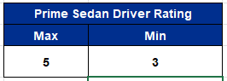

# 7. Retrieve all rides where payment was made using UPI: (Used Filter)

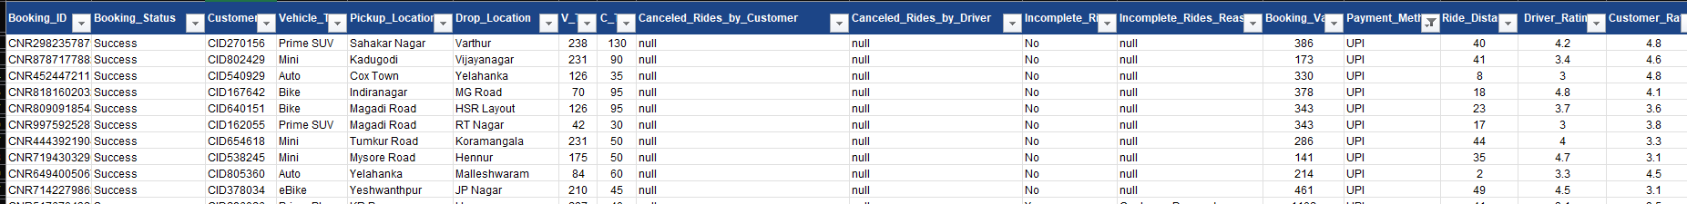

# 8. Find the average customer rating per vehicle type:

=AVERAGEIF(July!F:F,Analysis!C13,July!S1)

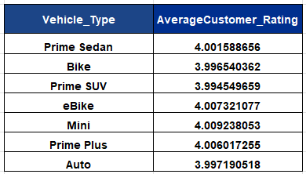

# 9. Calculate the total booking value of rides completed successfully:

=SUMIF(July!D:D,"=Success",July!O:O)

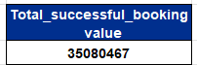

# 10. List all incomplete rides along with the reason (Used Filter)

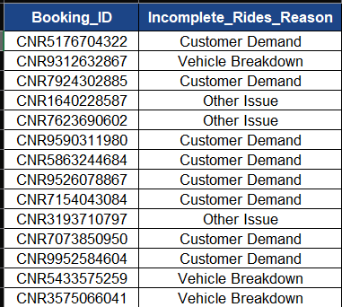

# 11. Find the most popular pickup and drop locations based on the number of rides.

-- Most Popular Pickup Locations (Used Pivot Table)

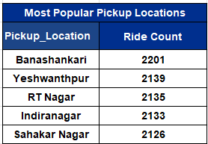

-- Most Popular Drop Locations (Used Pivot Table)

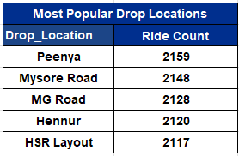

# 12. Get the percentage of successful bookings for each vehicle type.

=COUNTIFS(July!D:D,"=Success",July!F:F,Analysis!F15)/COUNTIF(July!F:F,Analysis!F15)*100

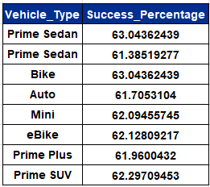

Also Done with Pivot Table: (=M5/COUNTIF(July!F:F,Analysis!L10) * 100)

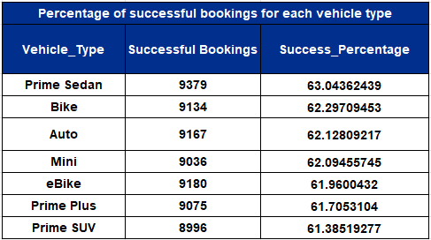

# 13. Retrieve the total number of bookings made for each day of the week.

=TEXT([@Date],"dddd") (And Used Pivot Table)

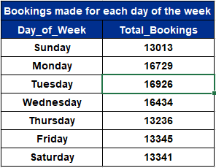

* **Analysis Sheet:**

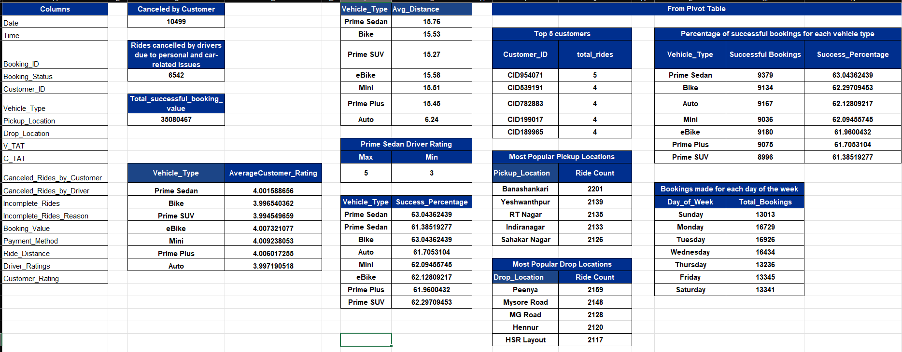

* **Pivot Table:**

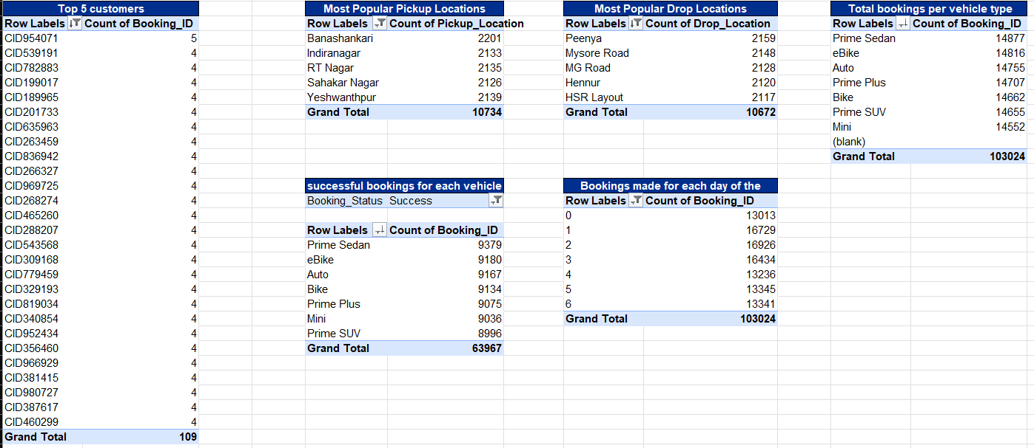

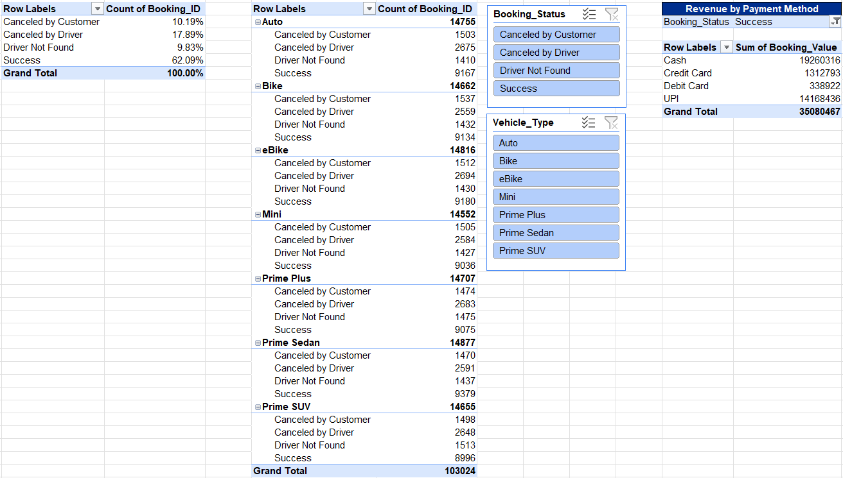

* **Charts:**

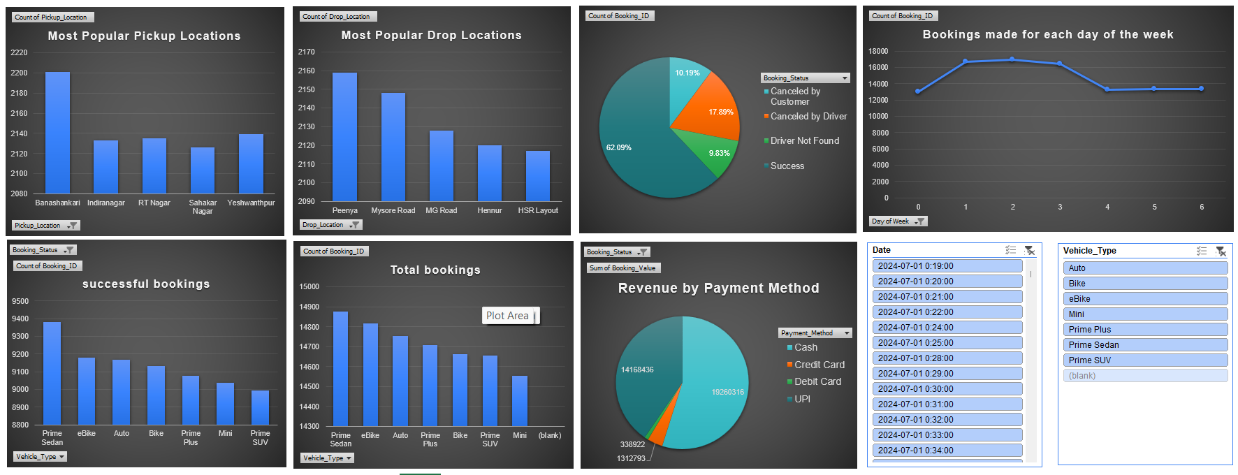

**Power BI Questions:**

1. **Ride Volume Over Time**

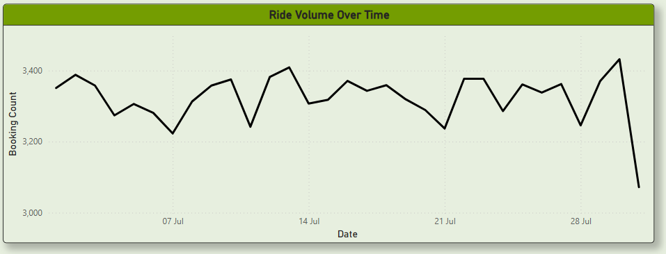

1. **Booking Status Breakdown**

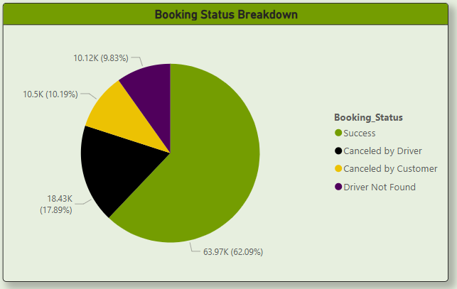

1. **Vehicle Types by Ride Distance**

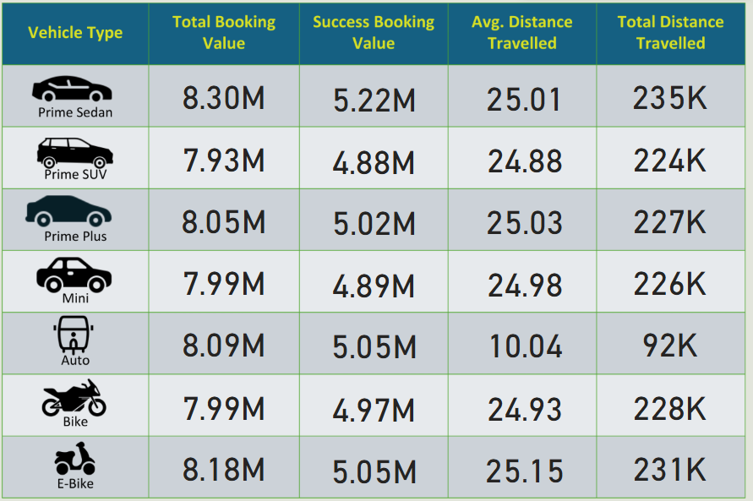

1. **Average Customer Ratings by Vehicle Type**

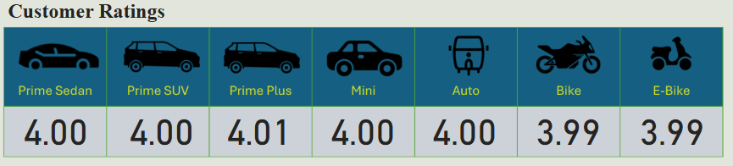

1. **cancelled Rides Reasons**

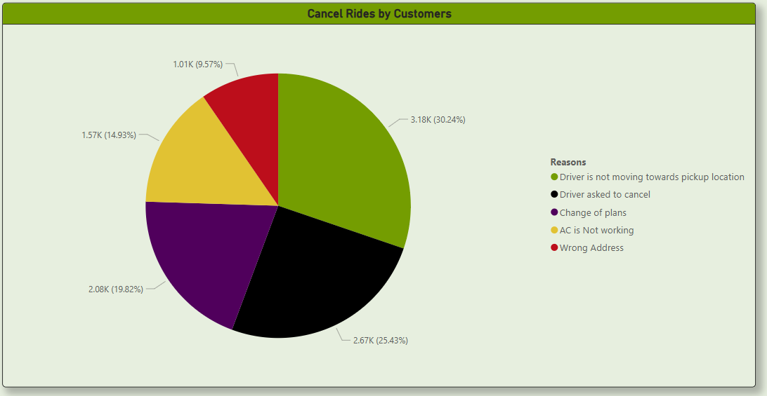

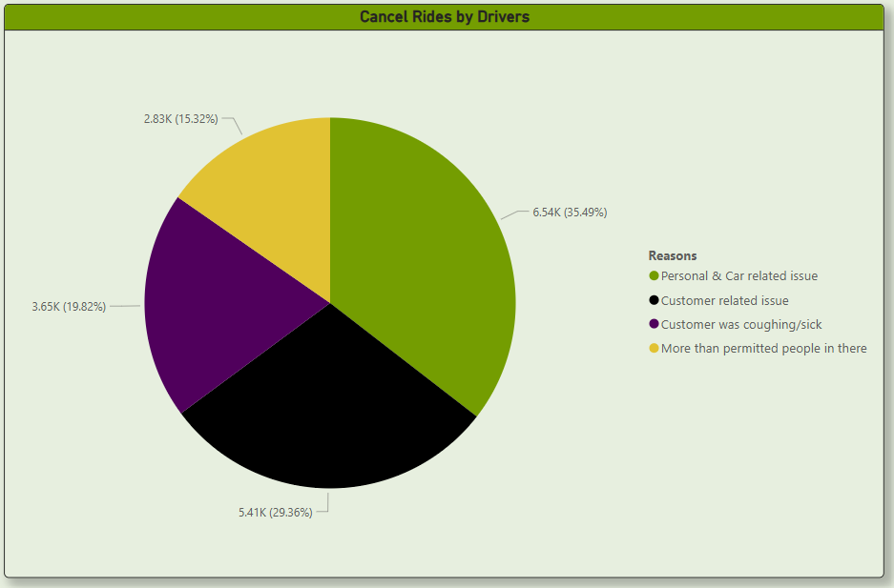

1. **Revenue by Payment Method**

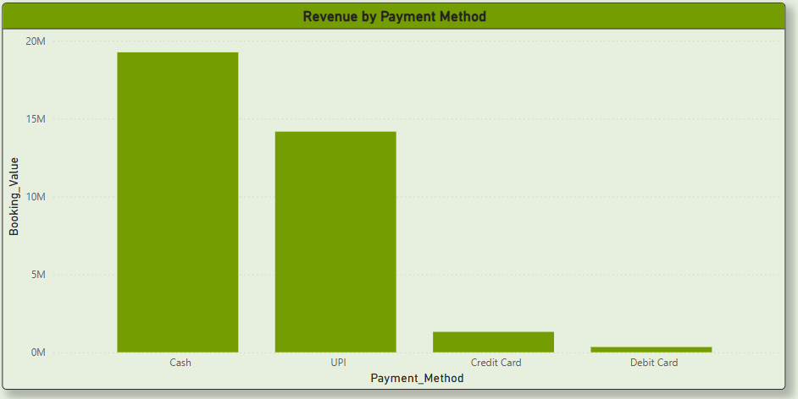

1. **Top 5 Customers by Total Booking Value**

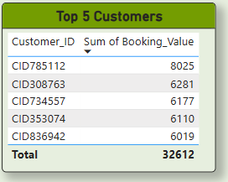

1. **Ride Distance Distribution Per Day**

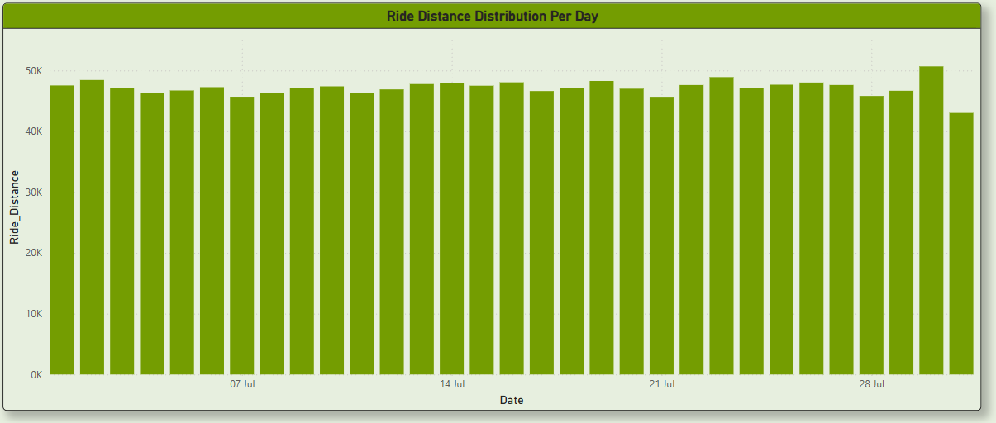

1. **Driver Ratings Distribution**

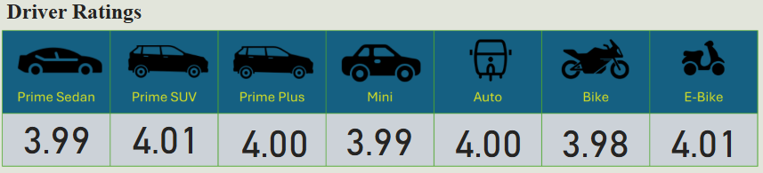

1. **Customer vs. Driver Ratings**

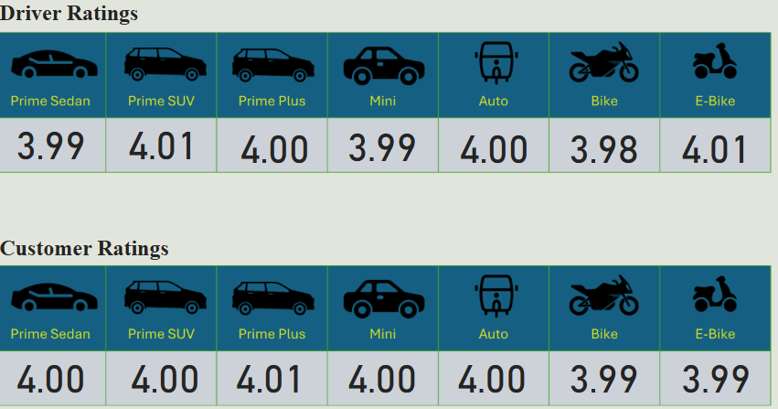

1. **Revenue Comparison Between Successful and Cancelled Rides**

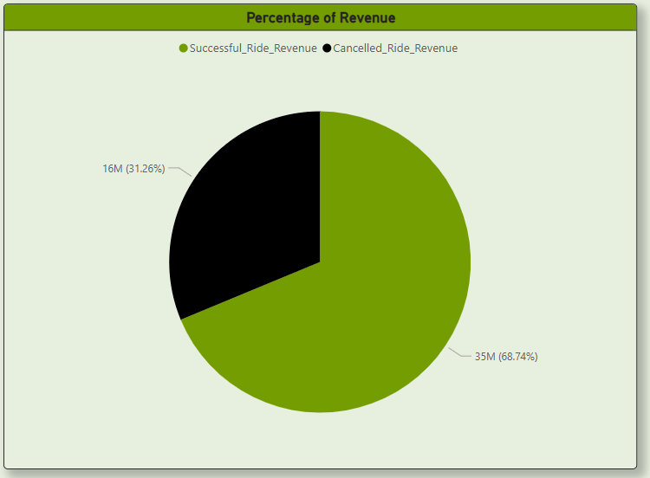

**Segregation of the views:**

1. **Overall**
   * Ride Volume Over Time
   * Booking Status Breakdown
   * Revenue Comparison Between Successful and Cancelled Rides
2. **Vehicle Type**
   * Vehicle Types by Ride Distance
3. **Revenue**
   * Revenue by Payment Method
   * Top 5 Customers by Total Booking Value
   * Ride Distance Distribution Per Day
4. **Cancellation**
   * Cancelled Rides Reasons (Customer)
   * Cancelled Rides Reasons (Drivers)
5. **Ratings**
   * Driver Ratings
   * Customer Ratings

**Dashboard:**

